Jason Moss

Joel Uyesugi

Ryan Dean

Vitaliy Gavrilov

Design Document

1. System Modeling

Use Cases

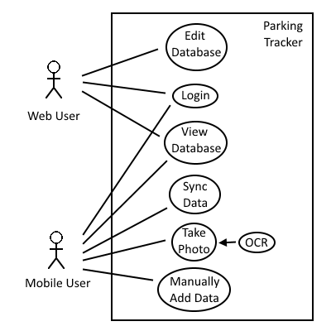

Data Flow

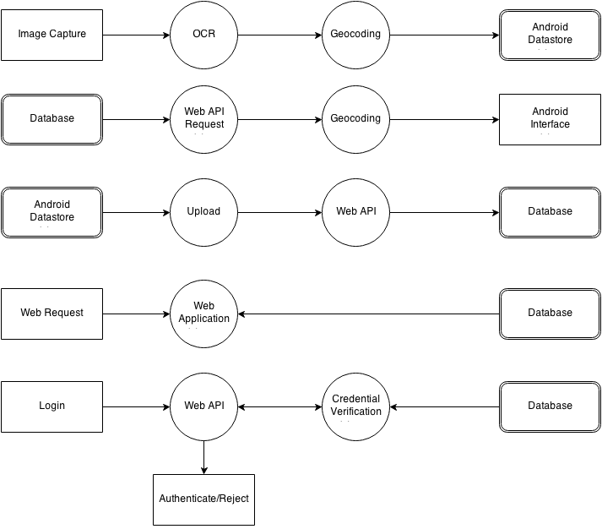

Subsystem Design

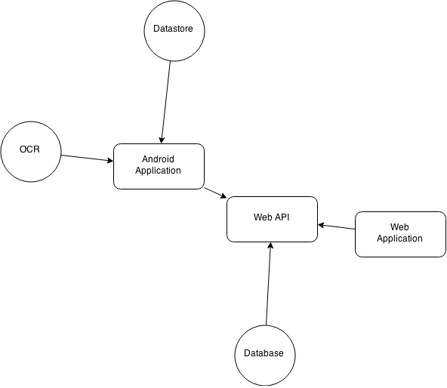

1. Schema Design

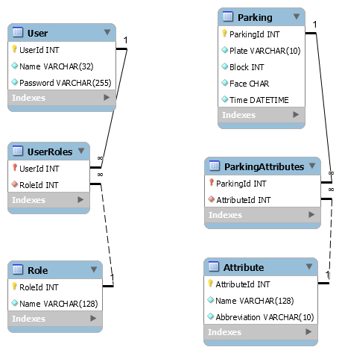

1. Interface Design

Interface Mockup

